Department of Aerospace Engineering Sciences

University of Colorado

ASEN 4018

Project Definition Document (PDD)

INFERNO

Approvals

|  |  |  |  |  |
| --- | --- | --- | --- | --- |
|  | **Name** | **Affiliation** | **Approved** | **Date** |
| **Customer** | Barbara Streiffert | Jet Propulsion Laboratory (JPL) |  |  |
| **Course Coordinator** | James Nabity | CU/AES |  |  |

Project Customers

|  |  |
| --- | --- |
| **BARBARA STREIFFERT**  ADDRESS  Email:  Phone: |  |

Team Members

|  |  |
| --- | --- |
| **Kaley Pinover**  [kaley.pinover@colorado.edu](mailto:kaley.pinover@colorado.edu)  303-482-6265 | **Esteben Rodriguez**  [esteben.rodriguez@colorado.edu](mailto:esteben.rodriguez@colorado.edu)  605-481-8760 |
| **Devon Campbell**  [deca8005@colorado.edu](mailto:deca8005@colorado.edu)  303-999-8626 | **Johnathan Thompson**  [johnathan.thompson@colorado.edu](mailto:johnathan.thompson@colorado.edu)  719-352-8158 |
| **Nick Peper**  [Nicholas.Peper@colorado.edu](mailto:Nicholas.Peper@colorado.edu)  303-242-4197 | **Kevin Mulcair**  [kevin.mulcair@colorado.edu](mailto:kevin.mulcair@colorado.edu)  970-402-6640 |
| **Adam Archuleta**  [Adam.Archuleta@colorado.edu](mailto:Adam.Archuleta@colorado.edu)  720-371-2658 | **Tess Geiger**  [m.geiger@colorado.edu](mailto:m.geiger@colorado.edu)  512-619-9797 |
| **Thomas Jeffries**  [thomas.jeffries@](mailto:kaley.pinover@colorado.edu)colorado.edu  303-482-6265 |  |

Table of Contents

Approvals 1

Project Customers 1

Team Members 1

Table of Contents 2

1 Problem/Need 3

2 Previous Work 3

3 Specific Objectives 3

4 Functional Requirements 4

4.1 Concept of Operations (CONOPS) 4

4.2 Functional Block Diagram 4

5 Critical Project Elements 5

5.1 Communications 5

5.2 Power System 5

5.3 FAA Certificate of Authorization (COA) 6

5.4 System Integration 6

5.5 Control System 6

6 Team Skills and Interests 6

7 Resources 6

8 References 7

NOTES 7

# Problem/Need

Wildfires are a highly prevalent, costly, and dangerous natural disaster in the United States, particularly in mountainous, difficult-to-access locations. Fire prevention and suppression efforts by the United States Forest Service currently total $320 million, and are projected to reach $1.8 billion by 2025. Not only is wildfire mitigation and containment expensive, but it requires personnel to enter hostile conditions to obtain information about the fire, which often results in casualties. In order to reduce the expense and human risk associated with wildfires, our project seeks to develop and implement an aerial drone-based data collection system for use in hazardous environments and areas impassible by ground-based methods.

Our project architecture is composed of four unique systems: a remote ground station, a mother rover, a flying child drone, and a sensor package. The remote ground station will serve as a deployment base for the mother rover, which will carry the child drone up to 500 m from the ground station’s location. The child drone will then take off from the holding bay of the mother rover, and fly for up to twenty minutes to a maximum distance of 200 m at a maximum speed of 10 m/s to a GPS location designated by the mother rover. The child drone will transmit time-stamped video and still frames of the area of interest to the ground station and will deploy a sensor package to the ground at the desired location. The sensor package will take and record temperature data at one second intervals for at least one hour. This data will then be transmitted to the ground station directly or indirectly through other system components. During flight and sensor delivery, the child drone will be controlled by an operator located at the ground station. All components will be designed for application in Earth-like environments.

# Previous Work

The Jet Propulsion Labratory (JPL) has been sponsoring rover projects since 2008. The rover projects sponsored by JPL have ranged from projects that have a child rover taking pictures and transmitting them back to a mother rover, to projects that have a mother rover deploy a child rover to repel down the side of a cave. The last mother rover that was built, called TREADS, supported two different child rovers and had the capability to store collected samples.

Autonomous delivery of packages is popular in today’s market with Amazon and DHL innovating new solutions each year. Both companies have achieved autonomous delivery to precise GPS coordinates within 10 miles, reaching speeds of 40mph, at an elevation of 50 meters. These rovers are capable of picking up and dropping off a package, with precision landing to “grab” these packages.[4] The electric power unit used in the project enables a flight time of up to 45 minutes. The DHL Parcelcopter can carry a load of up to 1.2 kg.[3]

GPS technology has become essential when piloting a UAS. Such technology can be used to instruct a drone where to fly, at what height, at what speed, and can even give hover instructions at each point.[5] These “waypoint maps” can be transferred between a computer’s digital mapping software and a drone. If wireless communication is put in place, these instructions can be sent to the drone from anywhere in the world.[2] Some examples are its use in agriculture, parcel delivery, environmental surveying, and aerial cinematography. There are dozens of companies that use and produce this software, such as DJI, Spreading Wings, Service Drone, Aerialtronics, Ardupilot, 3DRobotics, and MicroPilot.

# Specific Objectives

There are four different systems in this project: the Sensor Package (SP), the Child Drone (CD), the Mother Rover (MR), and the Ground Station (GS). Each system has their own set of requirements for mission success. The MR shall accept commands from the GS. The MR shall send data to the GS. The MR shall transmit commands to the CD. The MR shall receive data from the CD. The MR shall receive data from the SP.

The CD shall accept commands from the MR. The CD shall send data to the MR. The CD shall launch and land from the MR. The CD shall fit in the MR landing bay. The CD shall have a range of 200m. The CD shall have an endurance of 20 minutes. The CD shall travel to GPS targets. The CD shall hold position within 5m. The CD shall have a positional accuracy of 5m. The CD shall deploy the SP to the ground. The CD shall fly at speeds up to 10m/s. The CD shall land on flat terrain. The CD shall fly no higher than 400 ft AGL. The CD shall return to the last known mother position if contact is lost. The CD shall be capable of the following states: idle, ready, performing, task complete. The CD shall take video during flight. The CD shall have a FOV greater than 100° with its camera.

The SP shall transmit data. The SP shall take data at ground level. The SP shall record at least 1 hour of data. The SP shall sample at 1 Hz. The SP shall sample with 8 bit resolution. The GS shall be able to receive data from the CD. The GS shall receive data from the MR. The GS shall send commands to the MR.

# Functional Requirements

## Concept of Operations (CONOPS)

The CONOPS diagram in Figure 4.1 below shows the full design motivation for INFERNO. The specific elements of this motivation are differentiated by their relevance to the defined scope of this project. Elements of the CONOPS, which fall outside of the project scope, such as the Mother Rover’s mobility requirements, will need to be simulated during system tests. The remaining deliverable elements shown in Figure 4.1 will be implemented and tested as functioning systems through both small-scale tests for individual design goals and as a full flight test scenario shown in the CONOPS diagram to validate the full system.

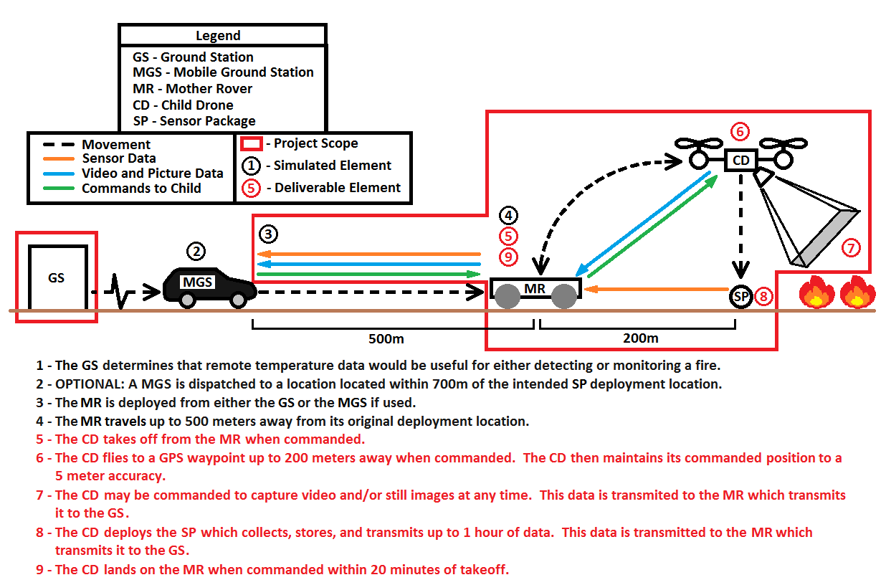

Figure 4.1 Project Concept of Operations (CONOPS)

## Functional Block Diagram

The full system will be composed of four primary component systems: the Ground Station (GS), the Mother Rover (MR), the Child Drone (CD), and the Sensor Package (SP). Commands sent by the GS will be relayed through the MR to the CD and SP. CD telemetry and imagery data, in turn, will be relayed back to the GS through the MR. Current requirements do not specify any pathway for SP telemetry data, except that it must return to the GS.

This project will be designing, building, and testing the CD and SP systems. The CD will likely be acquired as a commercial off-the-shelf (COTS) vehicle, which will then be modified as needed to enable the mission. The SP will be custom-built to meet mission requirements, using as many COTS components as possible. Command and communication through the GS and MR will be simulated by electrical and mechanical ground support equipment (EGSE and MGSE) in order to enable system-level testing of the CD and SP.

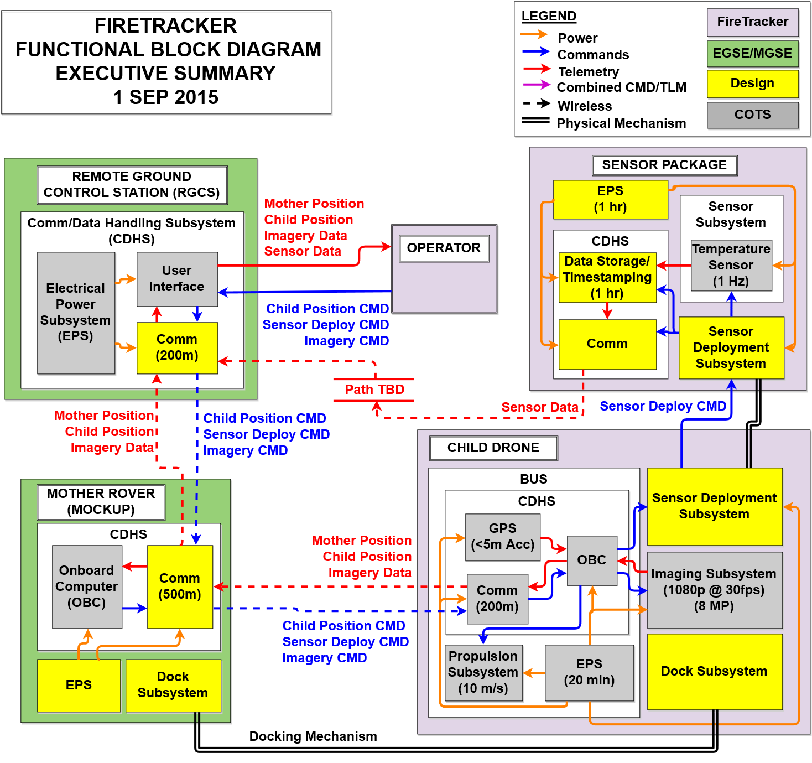

**Figure 4.2 INFERNO Functional Block Diagram**

# Critical Project Elements

## Communications

The CD must be able to wirelessly communicate with the MR, the GPS system, and possibly the SP. This may present a problem as a great deal of RF communication systems understanding will be required, and, at present, the team is largely unfamiliar with RF communication. This system will also be very demanding of the onboard power of the CD, thus perpetuating the critical aspect of power consumption. This will likely consume a larger portion of the project budget.

## Power System

The CD will require sufficient onboard power to operate the UAS in flight while receiving/transmitting information, as well as carrying a deployable payload. The ability of the CD to carry the added weight of a load of batteries to support these power needs is of critical importance. This is further complicated by the fact that, in addition to the deployable SP, the CD must also carry a camera capable of photo and video data acquisition, a GPS transmitter/receiver, and a sufficiently large antenna to communicate with the MR. The power system will consume moderate funding and time.

## FAA Certificate of Authorization (COA)

The CD must have proper documentation to take flight in public airspace. Due to the fact that the CD will be an airborne system, the team will need to acquire sufficient FAA permission to fly in the form of a COA. This process may be very time intensive and is critical to mission success; minimal/no funding will be required for the COA.

## System Integration

All of the mission systems/subsystems must be properly integrated. This may prove difficult to achieve with such a wide variety of mission components and technical aspects; if any one system is not properly integrated/designed, it will likely cause the overarching mission objective to fail. If the team purchases an existing UAS, all components must be able to interface with this device seamlessly which will require significant modification of the base design. If the team builds a UAS from the ground up, all components must be designed with careful consideration of each of the other components throughout the development process. This will require multiple trade studies to weigh the options and will prove very time intensive but will require minimal funding.

## Control System

The CD must be controllable while out of visual range of the GS. Any level of success will require controllability of the drone, whether autonomously or manually. Initially the team will implement a manual control system, which will require continuous photo/video feed from the CD to the GS, requiring significant bandwidth and power consumption. For level 3 success, the team will implement an autonomous flight regime allowing the CD to move to designated waypoints without human interfacing. This mode of flight will require intensive software in a form which the team is largely unfamiliar with.

# Team Skills and Interests

|  |  |  |  |
| --- | --- | --- | --- |
| **Name** | **Major** | **Skills / Interests** | **CPEs** |
| K. Pinover | ASEN | Communications planning and software package design for complex system modeling. Experience in systems engineering, mission design, trade studies, and financial management. Interest in communications and imbedded software. | 5.1, 5.2, 5.4, 5.5 |
| N. Peper | ASEN | Software application and development, and communication subsystem design. Interest in electronics and embedded software implementation. | 5.1, 5.2, 5.4, 5.5 |
| T. Geiger | ECE | Experience in electronic system design and embedded systems. Software proficiency in C and Assembly. | 5.1, 5.2, 5.3, 5.4 |
| D. Campbell | ASEN | Experience in embedded systems, microcontroller design, and LabView software development. Minoring in Applied Mathematics with an interest in electronics. | 5.2, 5.4, 5.5 |
| A. Archuleta | ASEN | CAD experience, mechanical design, and is machine shop certified. Interested in robotics. | 5.4, 5.5 |
| J. Thompson | ASEN | Extensive experience in wireless communication and swarm robotics, microcontroller design, and machining. Minoring in Computer Science. | 5.1, 5.2, 5.4, 5.5 |
| K. Mulcair | ASEN | Software development in C, C++, and Matlab. Complex system modeling and electrical and mechanical test engineering experience. Interest in systems engineering. | 5.2, 5.4, 5.5 |
| E. Rodriguez | ASEN | Experience in structural design and analysis, including Finite Element Method and manufacturing. Leadership experience; interest in systems design. | 5.2, 5.3, 5.4 |
| T. Jeffries | ASEN | Experience in management, leadership, and requirements definition. Prior customer experience; minoring in Applied Mathematics with an interest in systems engineering, software, and electronics. | 5.2, 5.3, 5.4 |



# Resources

|  |  |  |
| --- | --- | --- |
| **Project Elements (PEs)** | **Resources** | **Explanation** |
| **Technical PEs** | | |
| Operations Concept | Barbara Streiffert (Customer) | Necessary to define CONOPS |
| Senior Projects Advisor | Resource to help define obtainable project goals |
| Component Design and Testing | Bobby Hodgkinson | Resource for technical help with machining, manufacturing, and electronic component design |
| Trudy Schwartz | Resource for technical help with electronic component design |
| Matt Rhode | Resource for technical help with machining and manufacturing |
| Aerospace Lab | Location to perform circuit board fabrication and component manufacturing |
| **Logistical PEs** | | |
| FAA Certificate of Authorization (COA) | Eric Frew & James Mack | Knowledge of COA regulations |
| Testing | James Mack | Pilot |
| Eric Frew | Knowledge of possible test locations |
| Nick Peper’s House | Possible test location |
| Financial | Engineering Excellence Fund (EEF) *if necessary | Additional funding |

# References

[1] *The Rising Costs of Wildfire Operations: Effects on the Forest Service's Non-Fire Work*. U.S. Forest Service, 4 Aug. 2015. Web. Accessed 29 Aug. 2015. <http://www.fs.fed.us/sites/default/files/2015-Rising-Cost-Wildfire-Operations.pdf>.

[2] "DHL PARCELCOPTER 2.0." *Jebiga Design Lifestyle*. Web. 3 Sept. 2015.

[3]Kuhlmann, Dunja. "DHL Parcelcopter Launches Initial Operations for Research Purposes." *Deutsche Post DHL Group*. DHL, 24 Sept. 2014. Web. 29 Aug. 2015.

[4] Rui, He. *Mechatronics and Mechanical Engineering Selected, Peer Reviewed Papers from the 2014 International Conference on Mechatronics and Mechanical Engineering (ICMME 2014), September 6-8, 2014, Chengdu, China*. 2014 ed. 2014. Print.

[5]Corrigan, Fintan. "Drone Waypoint GPS Navigation Technology And Uses Explained." *DroneZoncom*. 30 Nov. 2014. Web. 29 Aug. 2015.

NOTES

Kaley – communications, electronics, software, leadership skills, finance, systems engineering, mission architecture / engineering

Nick – software (interested in embedded), interest in electronics, communications subsystem design

Tess – electronics, software, embedded software, assembly language

Devon – embedded systems, microcontrollers, LabView, a math minor, leadership, interest in electronics, parkour

Adam – CAD, machine shop certified, robotics interest

John - Extensive robotics experience, wireless communications and swarm robotics, microcontrollers, and machine shop experience

Kevin – C, C++, Matlab, modeling, test engineering, systems engineering

Esteben –software, structures, FEM, manufacturing skills, leadership, structural interests, mechanical design, systems design

Thomas – software, electronics, management, leadership, requirements definition, customer experience, interested in systems engineering, mission architecture, math minor

**\*this section is only for developmental use and will not be included in the final document**